**Exercise 1: Implementing the Singleton Pattern**

**Logger.java**

public class Logger {

private static Logger *logger*;

private Logger(){}

public static Logger getInstances(){

if(*logger*==null){

*logger* = new Logger();

}

return *logger*;

}

public void logMessage(String message){

System.*out*.println("Message from Logger Class: "+message);

}

}

**Main.java**

public class Main{

public static void main(String[] args) {

System.*out*.println("-----------OUTPUT--------------");

Logger logger1 = Logger.*getInstances*();

logger1.logMessage("First Logger");

Logger logger2 = Logger.*getInstances*();

logger2.logMessage("Second Logger");

if (logger1 == logger2) {

System.*out*.println("Both logger instances are the same.");

} else {

System.*out*.println("Different logger instances exist.");

}

}

}

**Output**

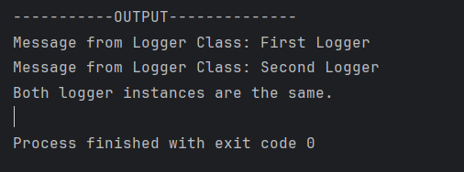

**Exercise 2: Implementing the Factory Method Pattern**

**Document.java**

package Document;

public interface Document {

void open();

}

**ExcelDocument.java**

package Document;

public class ExcelDocument implements Document{

@Override

public void open() {

System.*out*.println("Excel Document");

}

}

**PdfDocument.java**

package Document;

public class PdfDocument implements Document{

@Override

public void open() {

System.*out*.println("Pdf Document");

}

}

**WordDocument.java**

package Document;

public class WordDocument implements Document{

@Override

public void open() {

System.*out*.println("Word Document");

}

}

**DocumentFactory.java**

package Factory;

import Document.Document;

public abstract class DocumentFactory {

public abstract Document createDocument();

}

**ExcelDocumentFactory.java**

package Factory;

import Document.*;

public class ExcelDocumentFactory extends DocumentFactory {

@Override

public Document createDocument() {

return new ExcelDocument();

}

}

**PdfDocumentFactory.java**

package Factory;

import Document.*;

public class PdfDocumentFactory extends DocumentFactory {

@Override

public Document createDocument() {

return new PdfDocument();

}

}

**WordDocumentFactory.java**

package Factory;

import Document.*;

public class WordDocumentFactory extends DocumentFactory {

@Override

public Document createDocument() {

return new WordDocument();

}

}

**Main.java**

import Document.Document;

import Factory.DocumentFactory;

import Factory.ExcelDocumentFactory;

import Factory.PdfDocumentFactory;

import Factory.WordDocumentFactory;

public class Main {

public static void main(String[] args) {

System.*out*.println("----------------OUTPUT-----------------------");

DocumentFactory wordFactory = new WordDocumentFactory();

Document wordDocument = wordFactory.createDocument();

wordDocument.open();

DocumentFactory pdfFactory = new PdfDocumentFactory();

Document pdfDocument = pdfFactory.createDocument();

pdfDocument.open();

DocumentFactory excelFactory = new ExcelDocumentFactory();

Document excelDocument = excelFactory.createDocument();

excelDocument.open();

}

}

**Output**

